BabyCakes Cupcakes

All of our BabyCakes Cupcakes are handmade, using the finest ingredients available. We create our cupcakes in small batches to ensure that each bite is perfect. Our Doggie Cakes are made the same way. We believe that cupcakes should be a part of everyday happiness. Maybe our Summertime, Princess or our Oh-La-La cupcake will be your new happy.
*Please check website for daily offerings

- Baby Cakes Cupcakes - $2.00 per cupcake, $22.00 per dozen *minis $11.00 per dozen upon order

- Cocktail Cupcakes - $2.50 per cupcake, $27.50 per dozen

- Doggie Cakes - $1.00 per cupcake, $.50 per mini

- Fondant Cupcakes - $2.25 per cupcake, $25.00 per dozen *need 24 hour notice for fondant decorations

11:00 a.m. – 6:30 p.m. Tuesday thru Friday
10:00 a.m. – 4:00 p.m. Saturday

Check, cash and credit cards accepted
*24 hour notice for specially decorated cupcakes (i.e. fondant deco)
Cocktail Cakes

- Fun N' Sun- lime & rum cupcakes with a splash of orange topped with refreshing lime & rum buttercream

- Warm Fuzzies- dark chocolate cupcakes with a hint of kahula topped with chocolate kahula buttercream

- Morning Jolt- chocolate espresso cupcakes topped with coffee liquor mocha buttercream

- Jamaica Nights - spiced run cupcakes topped with chocolate dark rum buttercream

- Kentucky Pride- moist mocha cupcakes, topped with decadent caramel buttercream with a splash of Kentucky Bourbon

- Debutante's Ball -champagne cupcakes, champagne icing with a touch of strawberry

- Girk’s Night Out –margarehita cupcakes with lime and tequila

- Long Winter Nights –spiced cider and rum cupcakes

- Spike Cherry –cherry vanilla vodka cupcakes

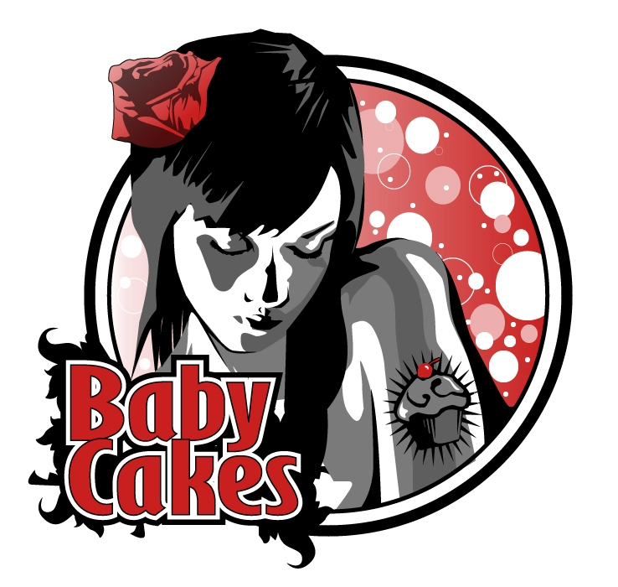
- Heavenly Angels –lemon, angel food cupcakes topped with glorious lemon glaze

- Southern Belle - red velvet cupcakes with glorious cream cheese icing

- Prom Night –orange chiffon cupcakes topped with glorious orange buttercream

- Tops N’ Tails –chocolate cupcakes topped with soft marshmallow cream, covered in hard scrumptious chocolate

- Summertime -splendid strawberry cupcakes with chocolate, vanilla or strawberry buttercream

- True Love -yummy chocolate cupcakes with light-as-air peanut butter frosting

- Karats Are a Girl's Best Friend -scrumptious carrot cake topped with decadent cream cheese icing

- Blondes Do Have More Fun -splendid lemon cupcakes with yummy lemon buttercream

- Auburn Beauties -pumpkin cupcakes topped with fabulous cream cheese icing. *seasonal

- Princess -heavenly chocolate cupcakes with your choice of buttercream icing

- Elvis & Priscilla -banana cupcakes topped with peanut butter buttercream and fudge sauce

- Bliss -moist white cupcakes with your choice of buttercream

- Oh-La-La -divine caramel cupcakes covered with buttercream and topped with homemade caramel sauce

- Sweet Dreams -comforting brownie cupcakes covered in vanilla buttercream

- Brazilian Goddess –chocolate cupcakes with a hint of chili topped with chocolate/chili icing

- Delightful Decadence-chocolate mint cupcakes with mint chocolate buttercream

- Autumn Love Affair- apple cupcakes with a caramel center, topped with

- Golden Brillance- butter pecan cupcakes with vanilla butter pecan buttercream

- Blue Eyed Beauties- vanilla cupcakes with fresh blueberries and vanilla buttercream
859.433.6190
153 Patchen Village
www.bb-cakes.com
*Gluten, Vegan and Sugar free available upon order
- To Germany with Love- moist German chocolate cake, filled with coconut love and all the trimmings.

- Formal Affair- scrumptious white cake swirled with delectable pure chocolate and topped with luscious buttercream

- Zen Moments- delectable chai tea cupcakes topped with yummalicious chai buttercream icing.

- Sweet & Sassy Redheads – glorious white chocolate raspberry cupcakes with raspberry or vanilla buttercream

- Sweet Indulgence- yummy chocolate chip cookie dough cupcakes with chocolate or vanilla buttercream

- Raven Haired Beauty- yummy blackberry cupcakes with blackberry buttercream

- Hemingway’s Eden- key lime cupcakes with key lime buttercream

- Fairy Tale Romance- black forest cupcakes filled with dark sweet cherries and topped with chocolate cherry buttercream

- Pink Ladies- pink lemonade cupcakes with pink lemonade buttercream

- Poconos Pleasure – hot chocolate cupcakes with a layer of buttercream, topped with whipped cream and fudge sauce

- Soda Shoppe Splendor- root beer float cupcakes with root beer buttercream buttercream

- Divine Aprhodite- luscious pear upside down cupcakes with vanilla buttercream

Happy Hour: Tuesday thru Thursday
5:30 to 6:30 (or until they are gone)
All remaining cupcakes are $1.00!!

